You've Been Called Here to be Perfected
November 23rd, 2022

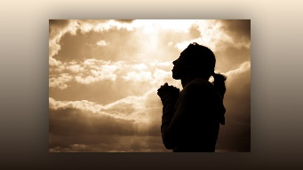
Precious Heart Dwellers, there are days when I see things, I want to make better, but I do not know how to go about it, and today was one of those days.

I said to the Lord, please speak to me Jesus, please let me hear Your sweet voice, I feel so inadequate leading this community.

Immediately I heard His voice and He said, “That is because you are not leading this community, I am. I am directing things and working on hearts. These things do take time, just like they did with you and Ezekiel. There are a lot of interior changes taking place, things are beginning to settle and bear fruit, although you cannot perceive it, there are good things happening, Clare.

“Anyone who comes to this mountain because they are serious about following God, I am serious about too,” He said. “I bring them here to a loving environment and allow their flaws to surface. It is much better if they are transparent and do not try to hide their short comings. I call them here because they want to go higher, but higher is not always easy, there has to be a willingness to change.

“Beloved ones, I have called you here to this community because I have so much more to give you in graces, so much more. But there needs to be a stripping away of self will and old habits. The people in this community have been handpicked by My mother and I, to make it a safe place to allow your faults to come to the surface, without condemnation, without one up man ship, cliques or attitudes.

“Everyone here loves everyone else, and they are all committed to growing spiritually and helping one another to grow as well. There are many simple people here who do not care about egos and posturing games, they are just very plain and dedicated to the Lord and one another. There will be times when you are discouraged by your faults and when you want to tuck in, cover up and pull away. But that is not necessary because everyone here is acutely aware of their shortcomings and humanity, and therefore it is safe for you to recognize your less than optimum attitudes and dispositions, and for you to do your best when you are corrected.

“I only correct those whom I love and want to draw up higher. I only correct when I see deep rooted problems that will keep you from entering Heaven but will send you to Purgatory.”

If children are getting what they need, a lot of the children in Africa are so starved, for the things that are necessary. A lot of orphans, dear ones, so many orphans.

God bless you, family.

